

**Reactions in Aqueous Solutions and Acids**

**Multiple Choice Question Booklet**

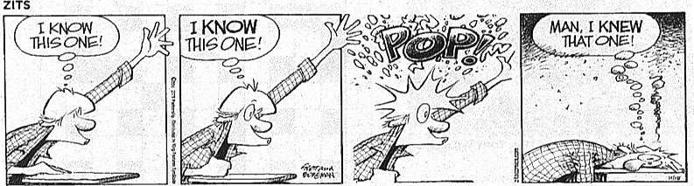

**PLEASE DO NOT TURN THE PAGE UNTIL INSTRUCTED TO DO SO**

**Part A: Multiple choice (15 marks)**

1. A solution of sodium chloride is described as ‘neutral’.

Which of the following **best** describes ‘neutral’.

1. The concentration of H+ ions is equal to the concentration of OH- ions.
2. The pH of the solution is 7.0 at all temperatures.
3. The solution does not show any effect on either red or blue litmus paper.
4. The solution produces a green colour when tested with universal indicator.
5. The pH of several substances is shown in the table below. Which is **incorrect**?

|  |  |  |
| --- | --- | --- |
|  | **Substance** | **pH** |
| a | aqueous ammonia | 11.6 |
| b | aqueous sodium chloride | 12.0 |
| c | dilute ethanoic acid (acetic acid) | 2.9 |
| d | dilute nitric acid | 1.0 |

1. Which of the following statements about types of acids is **true**?
2. Hydrofluoric acid is a strong acid
3. Hydrochloric acid is a weak acid.
4. Phosphoric acid is a monoprotic acid.
5. Sulfuric acid is a diprotic acid.
6. In which of the following reactions does hydrochloric acid **not** behave as an acid?

a) 2 HCl + CuCO3 ➔ CuCl2 + H2O + CO2

b) 2 HCl + Mg ➔ MgCl2 + H2

c) 2 HCl + Pb(NO3)2 ➔ PbCl2 + 2 HNO3

d) 6 HCl + Fe2O3 ➔ 2 FeCl3 + H2O

1. Ethanoic Acid (Acetic Acid) is referred to as a ‘weak’ acid because
2. It has a pH between 5 and 6.
3. It is not completely ionised in solution.
4. It reacts slowly with carbonates and metals.
5. It turns pH paper orange.
6. Two solutions X and Y are shown below.

|  |  |
| --- | --- |
| Solution | Description |
| X | 1.00 mol L-1 sulfuric acid |
| Y | 1.00 mol L-1 sodium hydroxide |

Should a sample of X, a sample of Y and a mixture of equal volumes of X and Y be tested with a few drops of Universal Indicator, what would be the colours observed?

|  |  |  |  |
| --- | --- | --- | --- |
|  | X | Y | Mixture of X and Y |
| a | orange | blue | green |
| b | orange | green | orange |
| c | red | violet | green |
| d | red | violet | orange |

1. Ronald classified four acids into the categories as shown.

|  |  |  |  |
| --- | --- | --- | --- |
| Monoprotic | | Diprotic | |
| Strong | Weak | Strong | Weak |
| H3PO4 | HNO3 | H2CO3 | CH3COOH |

How many of the above acids are incorrectly classified?

1. one
2. two
3. three
4. four
5. Which of the following ionic equations **best** represents the reaction between aqueous sodium hydroxide and dilute sulfuric acid?

a) 2 Na(aq) + 2 H+(aq) ➔ 2 Na+(aq) + H2(g)

b) 2 Na+(aq) + SO42-(aq) ➔ Na2SO4(aq)

c) H+(aq) + OH-(aq) ➔ H2O(l)

d) SO42-(aq) + 2 OH-(aq) ➔ H2O(l) + SO3(g) + O2(g)

1. The chloride and carbonate of a metal, M, are insoluble in water. The sulfate of the same metal M is soluble in water. By which method can the chloride of the metal M be prepared using the carbonate of the metal M as the starting reagent?
2. Add excess aqueous sodium chloride, then dilute sulfuric acid, then crystallise.
3. Add excess dilute carbonic acid, then dilute hydrochloric acid, then filter.
4. Add excess dilute sulfuric acid, then aqueous sodium chloride, then filter.
5. Add excess distilled water, then add lead(II) chloride, then heat gently.
6. Which of the following will have the lowest concentration of hydrogen ions?
7. NaOH (1 molL-1)
8. Pure water
9. Sodium hydrogen carbonate (1 molL-1)
10. Acetic acid (1 molL-1)
11. Which of the following statements is correct?
12. Sea water is slightly basic as it has a pH slightly less than 7.
13. Sodium carbonate is a weak base as it is only slightly soluble in water.
14. Rain water that turns blue litmus red has a [H+]>[OH-].
15. Barium oxide can react with acids and bases and is called an amphoteric oxide.
16. A solution may be described as:
17. A pure substance of constant composition.
18. A homogeneous mixture of uniform composition.
19. A substance which can be purified by filtration
20. A heterogeneous mixture of variable composition.
21. Which of the following equations is the correct representation of a strong acid?

(a) HI  H+ + I-

(b) NaOH  Na+ + OH**-**

(c) C2O4H2 2 H+ + C2O42-

(d) NaH2PO4  Na+ + 2H+ + PO43-

14. Nitrogen oxide gas combines with oxygen according to the equation

below. *All of the gases are at the same temperature and pressure.*



If 90 L of NO is reacted with 40 L of O2 the **volumes** of gases present after the reaction under the same conditions of temperature and pressure are:

|  |  |  |  |
| --- | --- | --- | --- |
|  | NO | O2 | NO2 |
| (a) | 80 L | 40 L | 80 L |
| (b) | 90 L | 40 L | 130 L |
| (c) | 0 L | 0 L | 130 L |
| (d) | 10 L | 0 L | 80 L |

15. The Arrhenius Theory of acids and bases was replaced due to its shortcomings. Which one of the following was one of these shortcomings?

(a)     Water is not always necessary in acid-base reactions.

(b)     An acid dissociates to form hydrogen ions (H+).

(c)     Weak acids and bases only partially dissociate.

(d)     A base dissociates to form hydroxide ions (OH**-**).

**END OF PART A CONTINUE WITH PART B**

**NAME:_______________________________**

TASK 15 : Test 5 Reactions in Aqueous Solutions and Gases

(Parts A & B)

TASK 16 : Research Assignment 4 (SHE 5)

(Part C)

MULTIPLE-CHOICE ANSWER SHEET

1. At an increased temperature, the average kinetic energy of the molecules increases.
2. At an increased temperature, the number of molecules with any given energy increases.
3. At an increased temperature, the number of molecules with the energy above any given increase.
4. At an increased temperature, the total area under the curve remains the same.

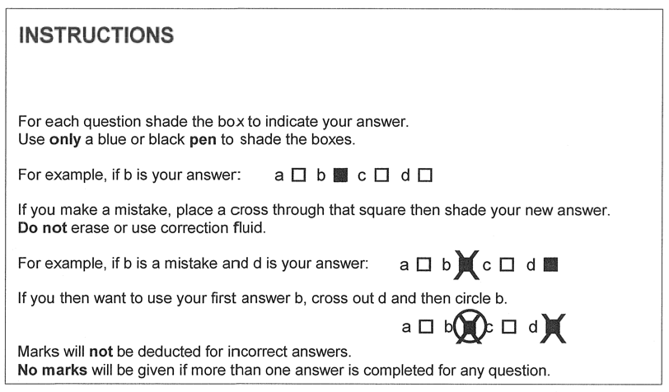

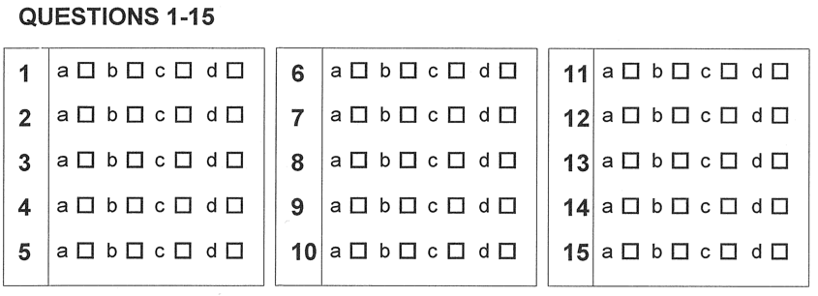

PART B. SHORT ANSWER SECTION (20 marks)

1. When a metal carbonate is added to a beaker containing dilute nitric acid, rapid effervescence occurs. A colourless gas is evolved.

(a) (i) Name the gas. _______________________________________________ (1)

(ii) Describe the test that is used to identify this gas. (1)

____________________________________________________________________________________________

____________________________________________________________________________________________

(b) An excess of marble chips is added, with stirring, to dilute sulfuric acid in a beaker. The graph shows the change in electrical conductivity of the solution in the beaker.

Electrical conductivity

P

Q R

Time

(i) Write a balanced Ionic equation for the reaction between marble chips (composed mostly of calcium carbonate) and dilute sulfuric acid. (2)

(states must be shown)

____________________________________________________________________________________________

(ii) Write an observation for the equation above. (1)

____________________________________________________________________________________________

____________________________________________________________________________________________

(iii) What causes the electrical conductivity to drop between P and Q? (1)

_____________________________________________________________________________________________

_____________________________________________________________________________________________

(iv) Why is there no change in electrical conductivity between Q and R? (1)

_____________________________________________________________________________________________

2. Ammonia gas is liberated when a solid mixture of ammonium sulfate and calcium oxide is heated.

1. Write an Ionic equation for the formation of ammonia gas. (1)

_____________________________________________________________________________________________

1. 4.80 L of ammonia gas was measured under standard conditions(STP), was dissolved in 250 mL of water.
2. Write an Ionic equation for the reaction of ammonia with water. (1)

____________________________________________________________________________

1. What is the effect of the solution in (b)(i) on litmus paper? Explain your answer. (1)

_____________________________________________________________________________

_____________________________________________________________________________

1. Calculate the number of moles of ammonia gas produced. (1)
2. 10.30g of solid magnesium sulfate was added to the ammonia solution. Calculate the concentration of the ammonium sulfate produced. (2½)

1. Calculate the concentration of the ammonium hydroxide solution required in part (iv). (1½)

3. 0.5055g of potassium nitrate, 0.6564g of calcium nitrate, and 0.1829g of cobalt(II) nitrate are dissolved in the same flask of water and the volume made up to 250.0mL.

(State answers to the appropriate number of significant figures)

1. Calculate the number of moles of each substance. (3)
2. Calculate the concentration of nitrate ions (in molL-1) (2)